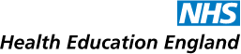
North, Central and East London
Clinical Oncology Training Programme

Our rotation provides a variety of posts at different centres across the region.
Your training will take place across a variety of our centres with the aim of spending at least 2 years at 2 different larger centres, in addition to a combination of any of the smaller centres. All centres provide excellent training opportunities in varied learning environments.
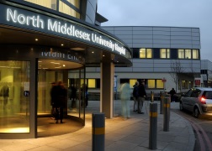
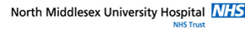
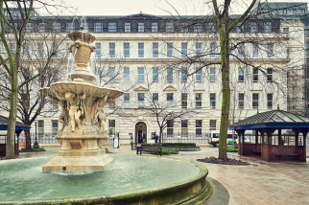
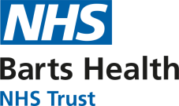
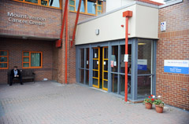
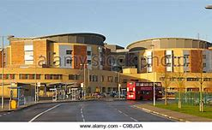
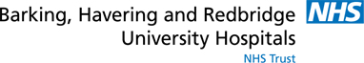
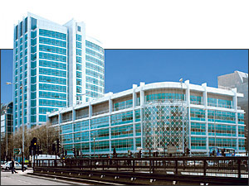
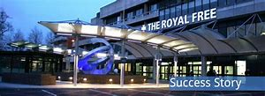
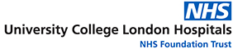
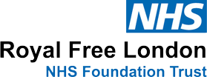
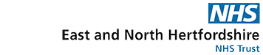
Our aim is for you to develop competencies required to become a Clinical Oncology Consultant. On completion of your training, you will be skilled in the non-surgical management of both common and rare tumours. This will involve experience in the use of systemic therapies, including conventional chemotherapy, immunotherapy and newer novel agents. The centres also offer state of the art radiation technologies, such as stereotactic radiotherapy and from 2020 proton beam therapy.
Clinical Oncology Training Programme
Queen’s Hospital, Romford
Mount Vernon Cancer Centre

In addition to learning through clinical attachments and local teaching sessions, we also offer more formal learning opportunities. This includes an MSc Oncology course, based at the Institute of Cancer Research and weekly attendance at this course is fully integrated during the first 2 years of training, aiming to support you with the FRCR exam and submission of a dissertation to attain an MSc. There are also 3 Regional Study half days for each specialist trainee, spread through each year of training, as well as more focused preparation for the FRCR part 2 examination and a dedicated pre-FRCR part 2 exam course with Consultant delivered teaching specifically tailored to the exam.
Research is integrated into Clinical Oncology practice and there will be plenty of opportunities to be involved in this whether during day to day clinical practice, where you receive broad experience in clinical trials or more formally by undertaking a research post. We actively encourage and support your career development and many of our trainees choose to some spend time ‘out of programme’ pursuing a postgraduate research degree, further leadership or teaching experience or specialist experience wither within the UK or overseas.

Our Support Structure
Throughout your training you will be supported by the Head and Deputy Head of School in Clinical Oncology, as well as our 2 Training Programme Directors (TPDs). Whilst at each centre you will be further supported by a College Tutor, overseeing the Clinical Oncology training there. You will, in addition, have a named Educational Supervisor and a named Clinical Supervisor for each attachment, providing day to day support for your learning needs. We have also introduced a Mentoring scheme, so that each new trainee will have the opportunity to have a senior trainee mentor to further support your transition to this speciality.
Below is a useful list of contacts. Please don’t hesitate to contact us.

Role | Name | Contact Details
Deputy Head of School | Dr Won-Ho  Edward Park | won-hoedward.Park@nhs.net
Training programme Director | Dr Nicola Anyamene | nanyamene1@nhs.net
Training programme Director | Dr Sugi Sivabalasingham | suganya.sivabalasingham@nhs.net
College Tutor Barts Hospital | Dr Paula Wells | paula.wells6@nhs.net
College Tutor Mount Vernon Hospital | Dr Anup Vinayan | anupvinayan@nhs.net
College Tutor North Middlesex Hospital | Dr Lucinder Melcher | lucinder.melcher@nhs.net
College Tutor Queen’s Hospital | Dr Simon Ball | simon.ball5@nhs.net
College Tutor Royal Free Hospital | Dr Sarah Needleman | sarah.needleman@nhs.net
College Tutor University College London Hospital | Dr Mark Gaze | mgaze@nhs.net

